**Muhammad Ahmad**

**21L-5617 BS(DS)7A**

**In-Lab Statement 1: Analyzing HTTP Protocol**

**Q1 :** The four protocols that appear in the unfiltered packet-listing window are TCP, HTTP, SNMP, and DNS.

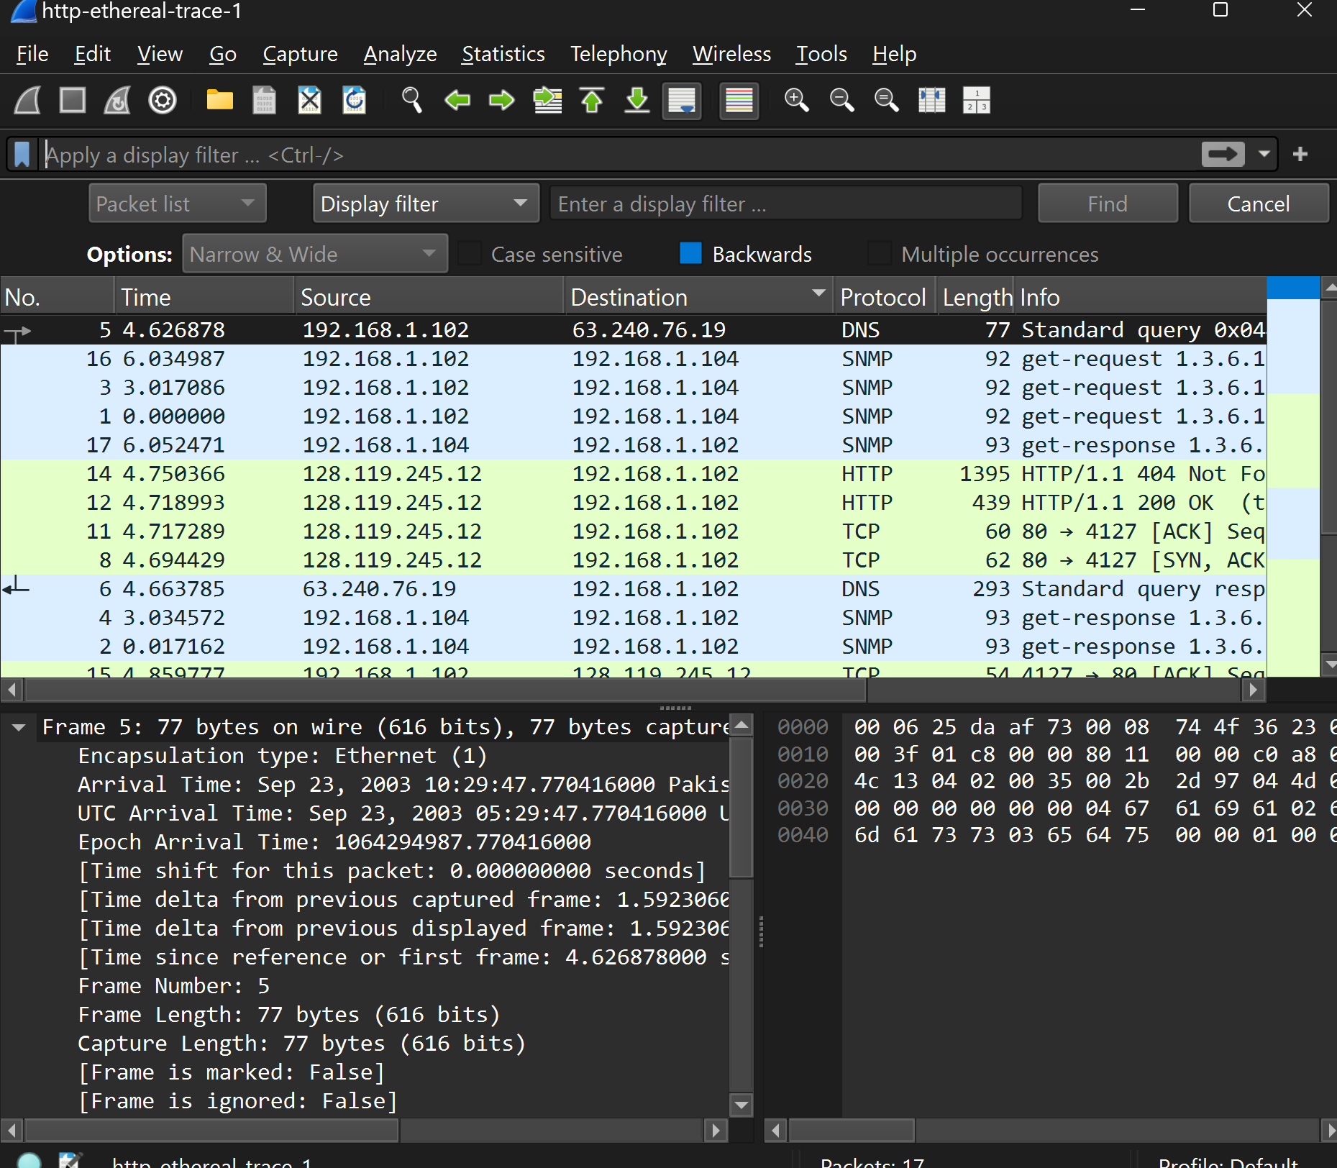

**Q2:** The time taken from when the HTTP GET message was sent until the HTTP OK reply was received is approximately **0.024 seconds**.

**Q3:** The second GET request was not successful, as indicated by the **404 Not Found** status in the response packet.

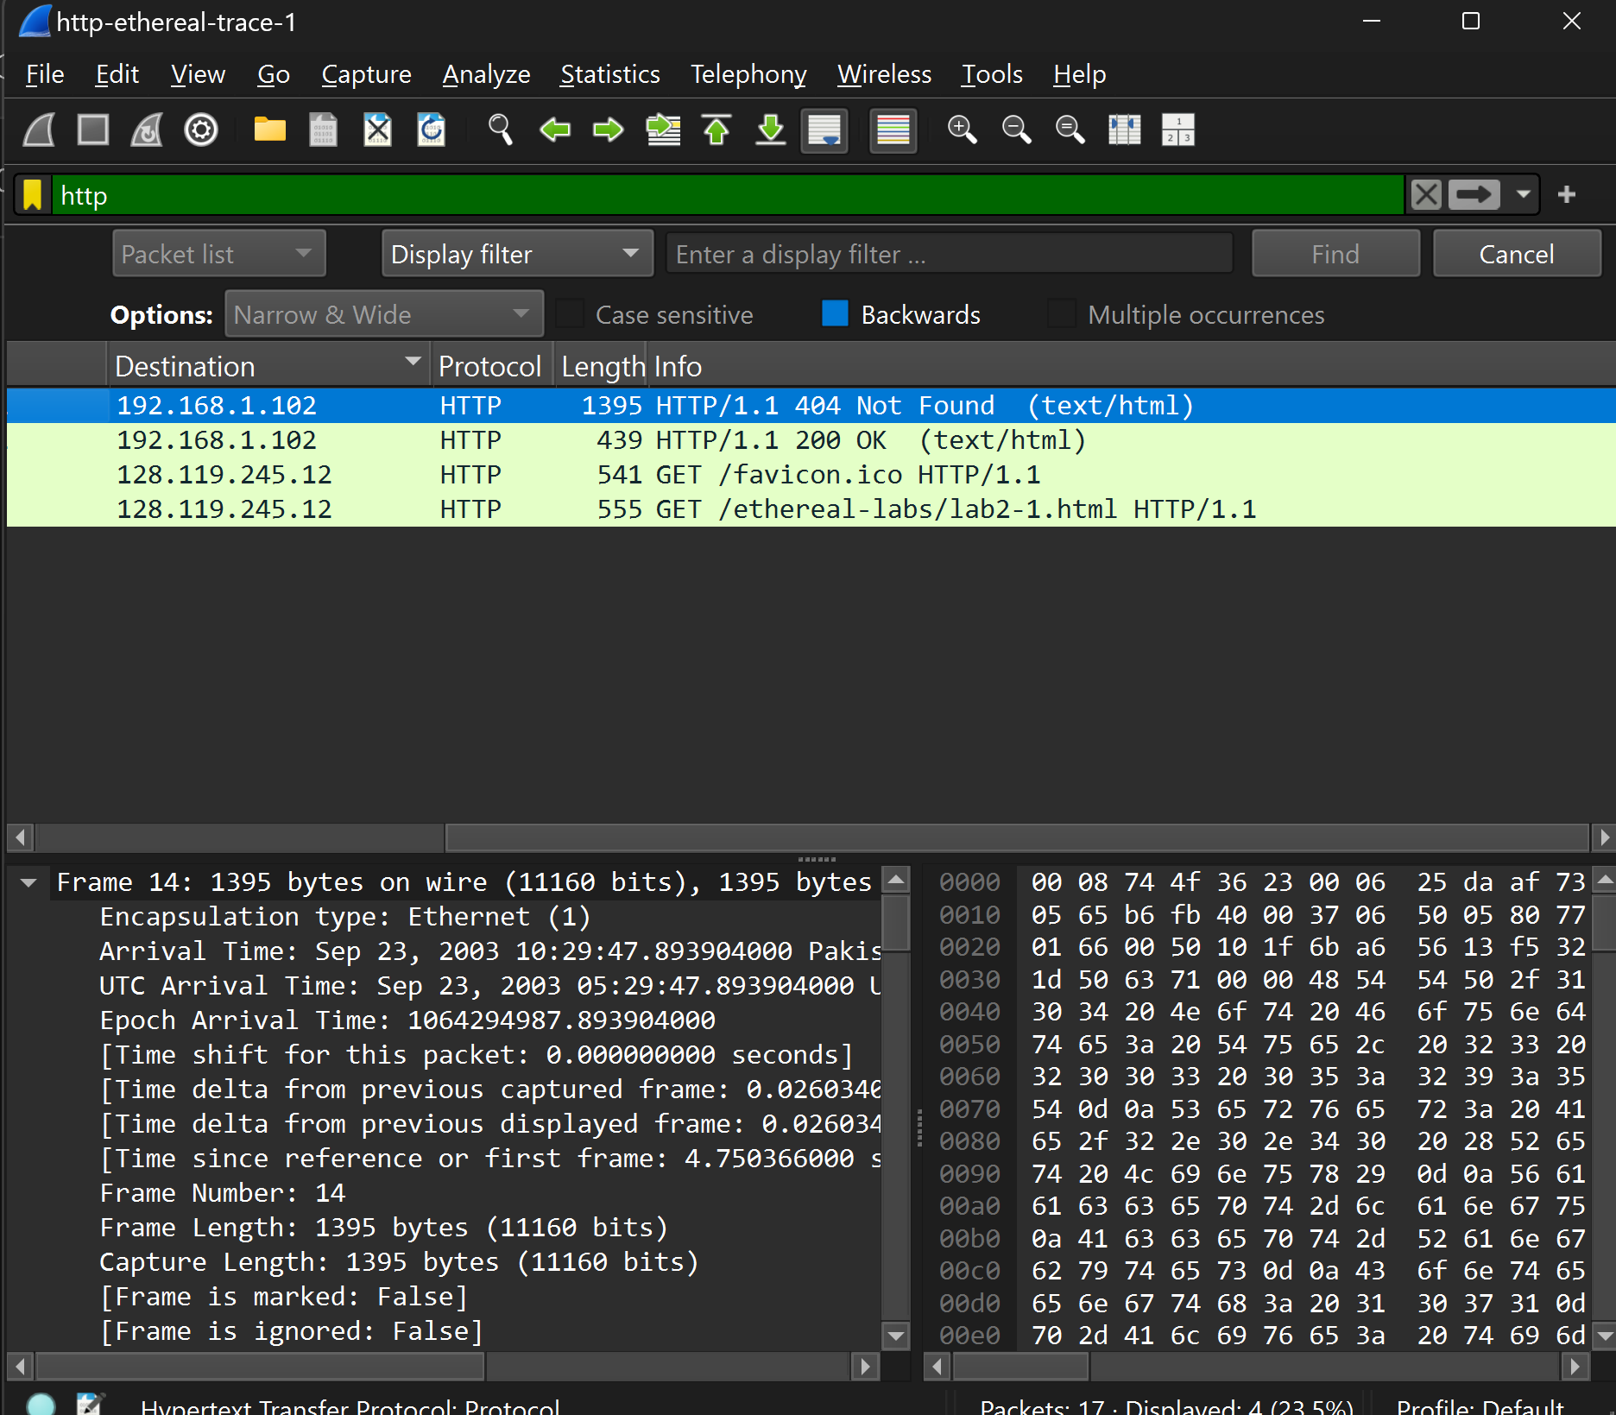

**Q4**: Both the browser and the server are running on **HTTP/1.1**.

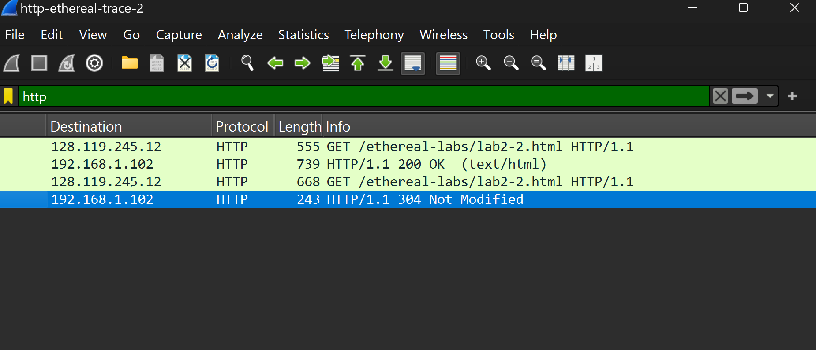

**Q5:** browser will request content in U.S. English first, but will also accept content in general English if U.S. English is not available

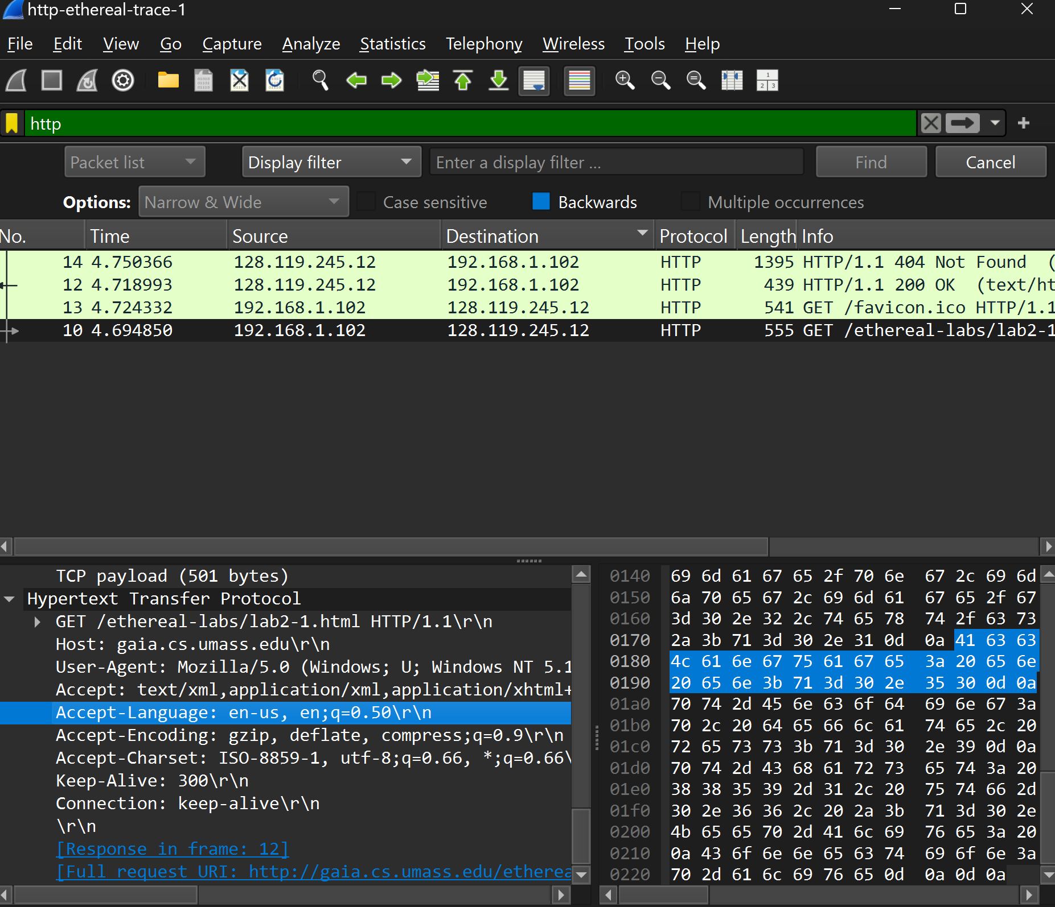

**Q6:**

• IP address of my computer: 192.168.1.102

• IP address of the gaia.cs.umass.edu server: 128.119.245.12



**Q7:**

• **MAC address of my computer (Source)**: 00:08:74:4f:36:23 (Dell_4f:36:23)

• **MAC address of the destination**  00:06:25:da:af:73 (LinksysGroup_da:af:73)

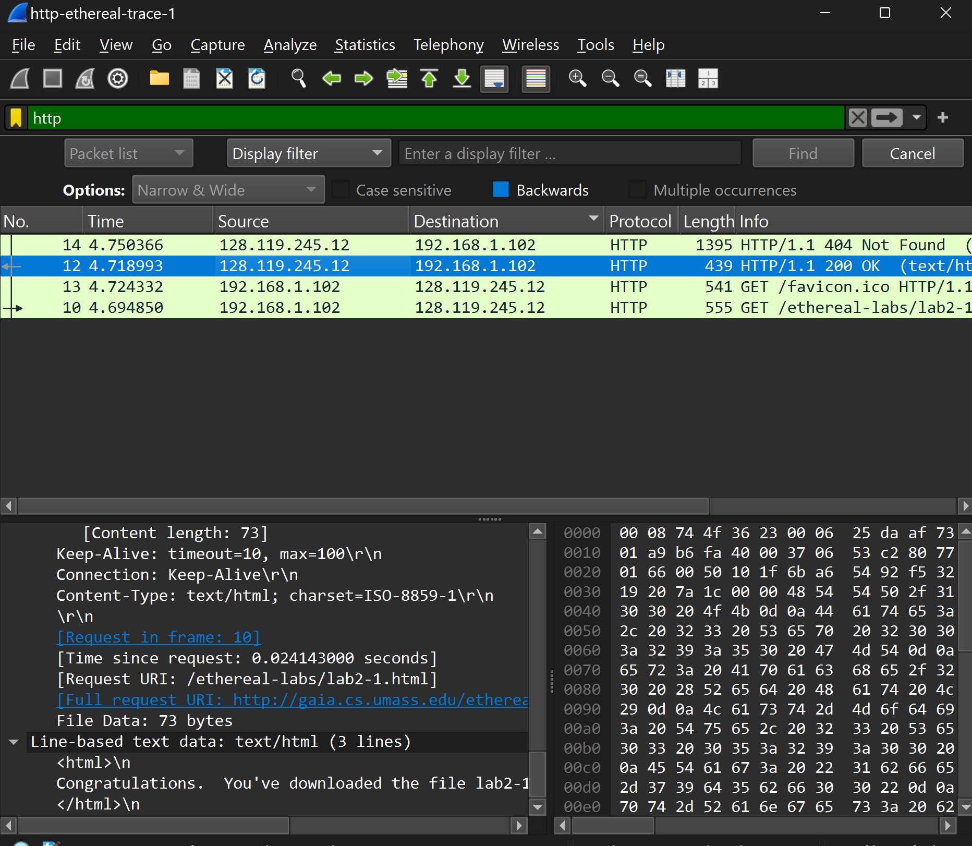

**Q8:**

* **Source Port**: 4127 (This is the port of my computer sending the request).
* **Destination Port**: 80 (This is the port on the server).

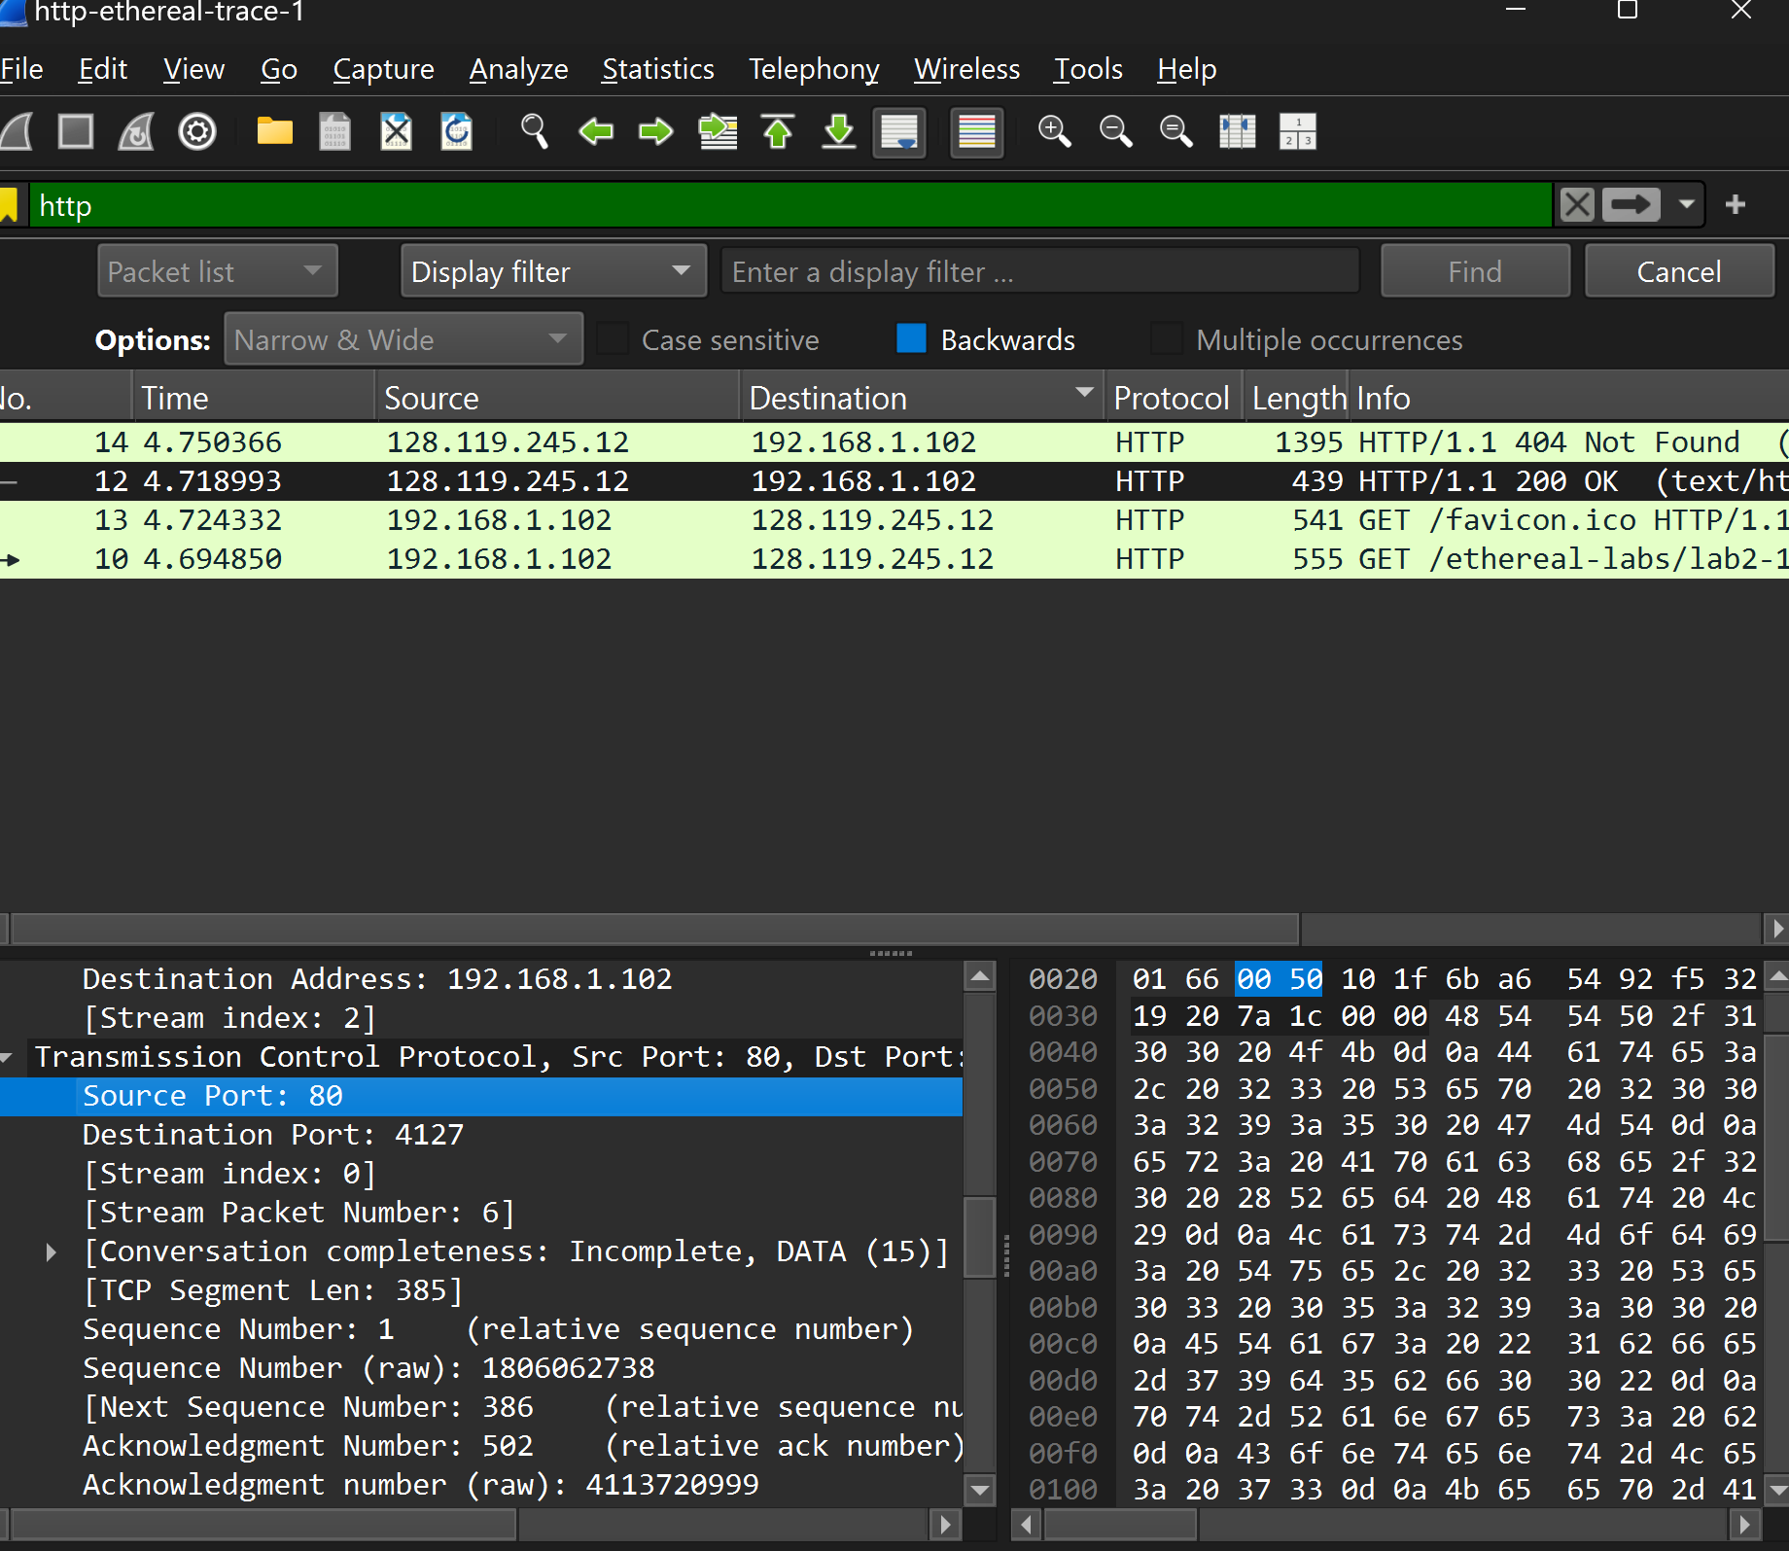

**Port 80:**

Port 80 is the default port for the **HTTP protocol**, which is used for standard web communication. When your browser requests a webpage, it typically sends the request to the server's port 80.

**Q9:** The status code returned from the server to my browser is **200**,



**Q10:** The HTML file that you are retrieving was last modified on the server on **Tue, 23 Sep 2003 05:29:00 GMT**

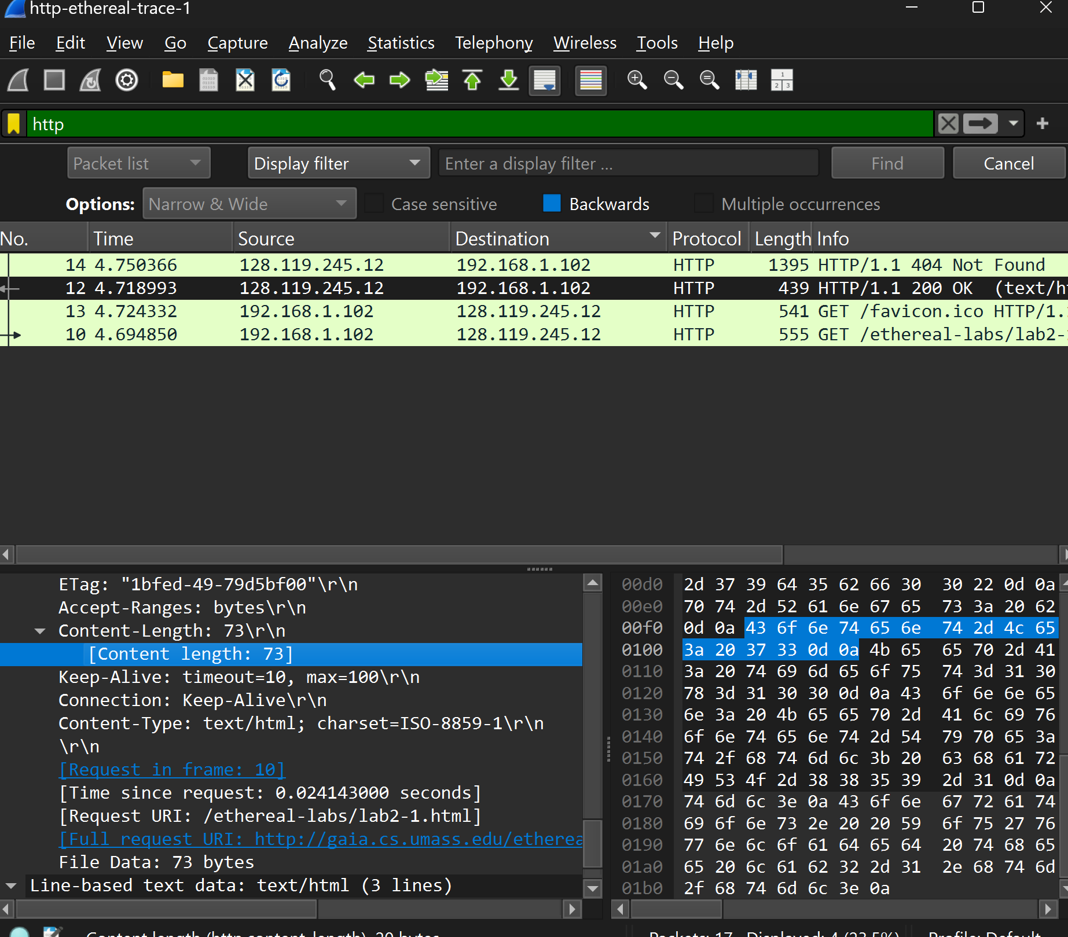

**Q11:** The total packet content being returned to my browser is **73 bytes**

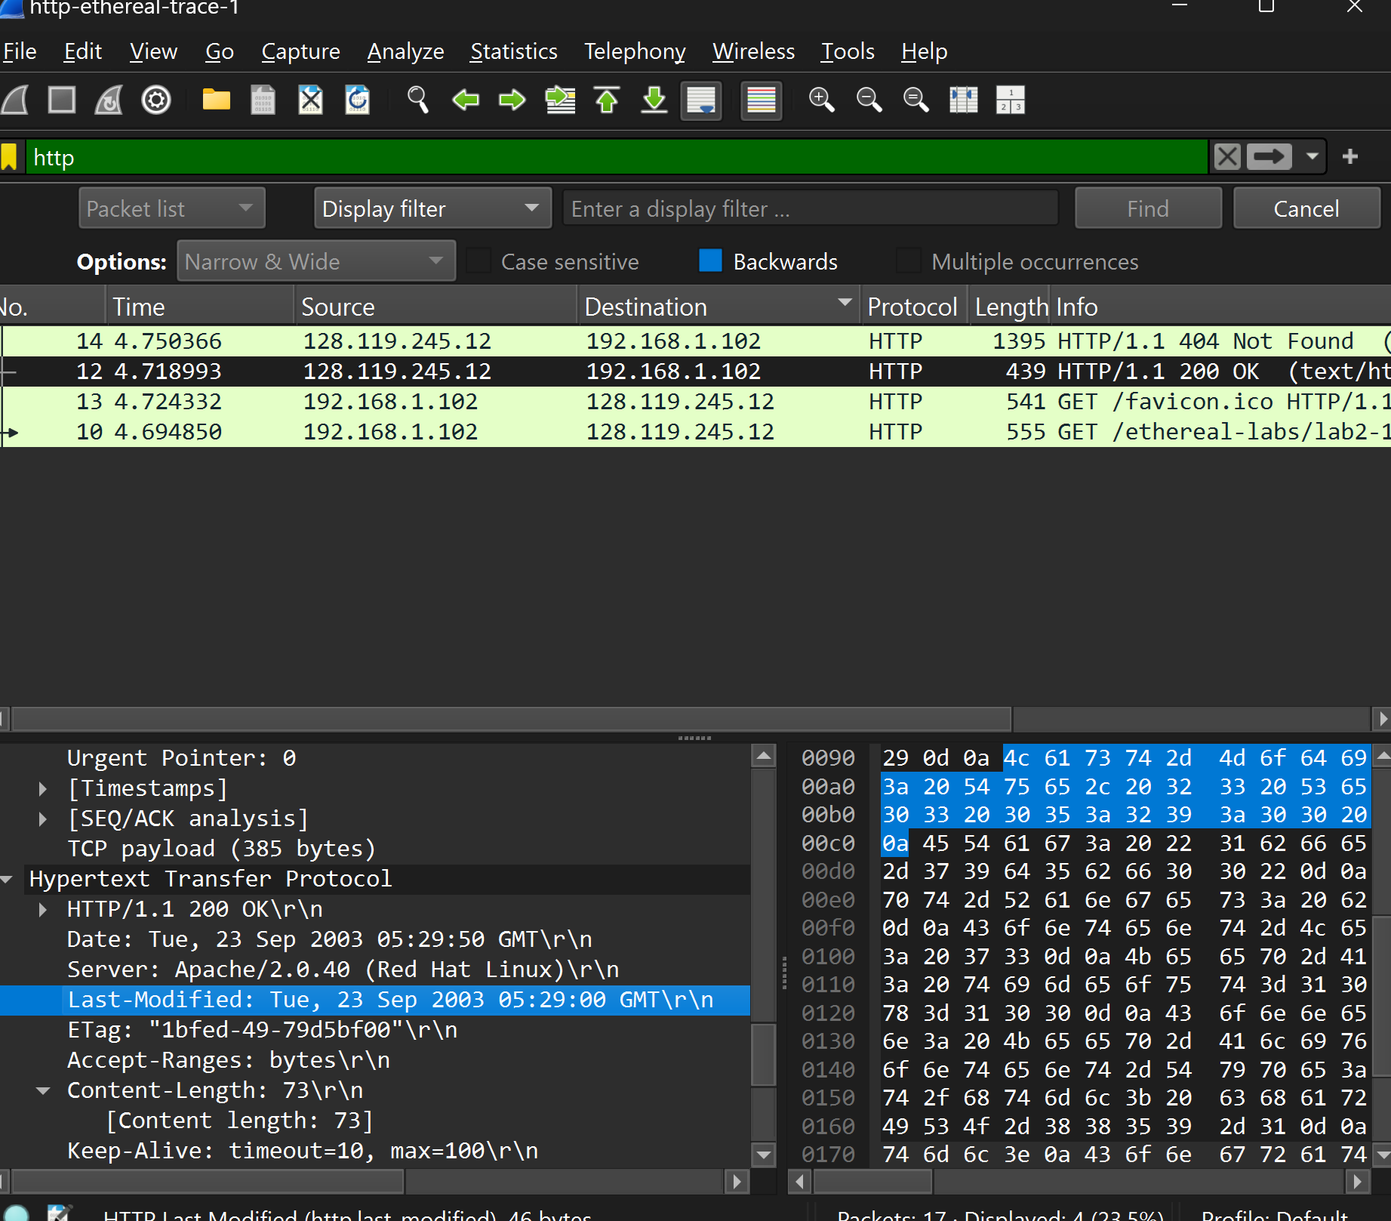

**The HTTP CONDITIONAL GET/response interaction**

**Q1:** No, there is no **"If-Modified-Since"** line in the first HTTP GET request from the browser to the server.

**Q2:** Yes, the server explicitly returned the contents of the file, as indicated by the presence of the text **"Congratulations again! Now you've downloaded the file lab2-2.html. <br>\n …."** in the Packet Bytes Window.

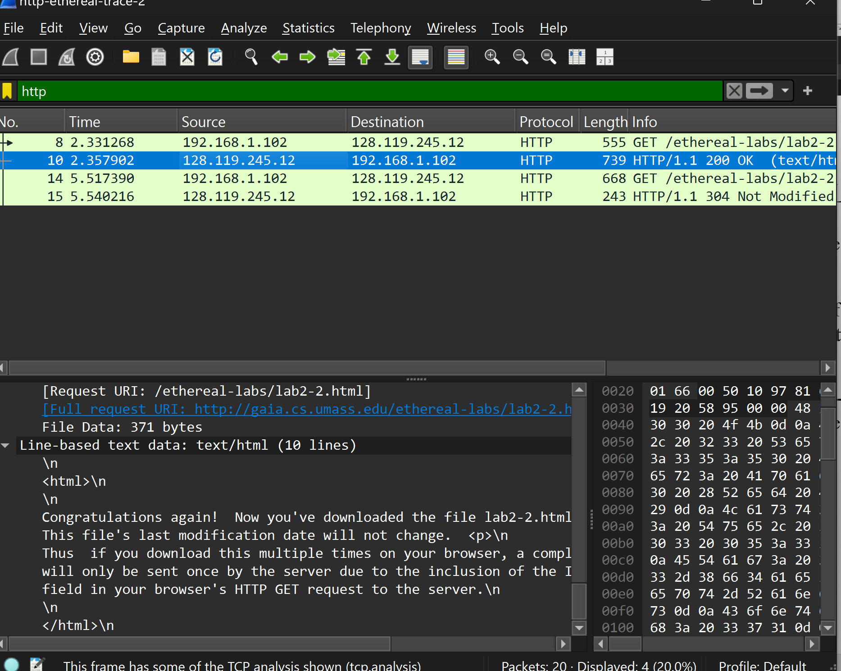

**Q3:** Yes, the second HTTP GET request includes **"If-Modified-Since: Tue, 23 Sep 2003 05:35:00 GMT."** This means the browser requests the resource only if it has been modified since that date

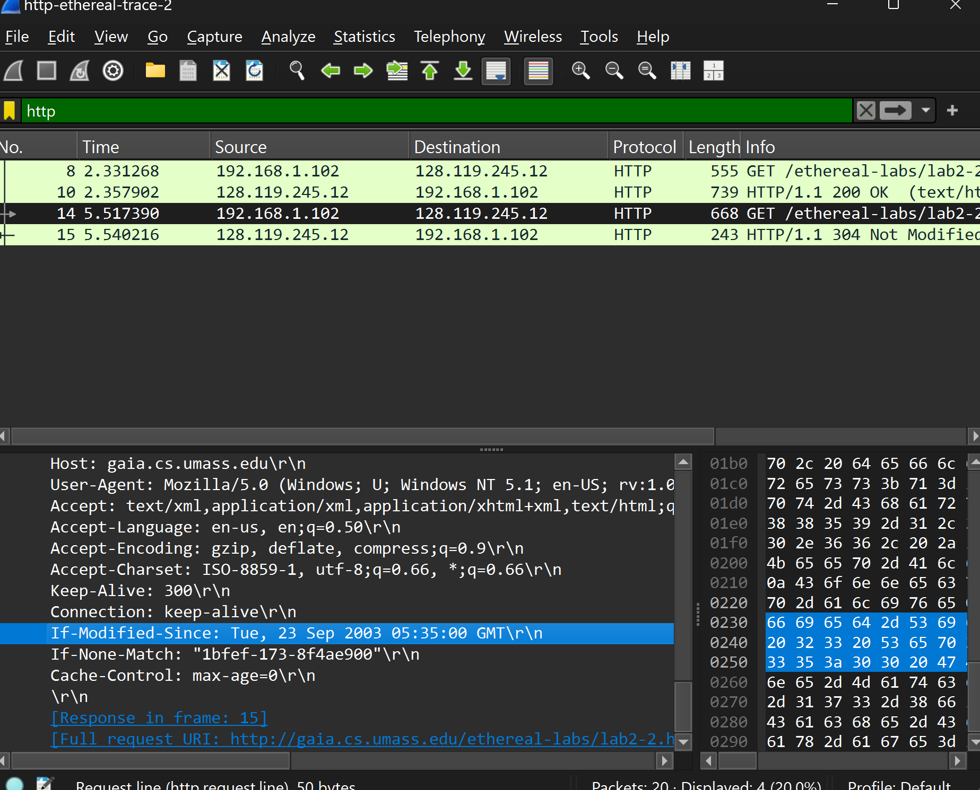

**Q4:**

The HTTP status code returned from the server in response to the second HTTP GET is **304 Not Modified**.

### Explanation:

The server did not explicitly return the contents of the file, as indicated by the **304 Not Modified** status. This means the resource has not changed since the date specified in the **If-Modified-Since** header, so the browser should use its cached version instead.

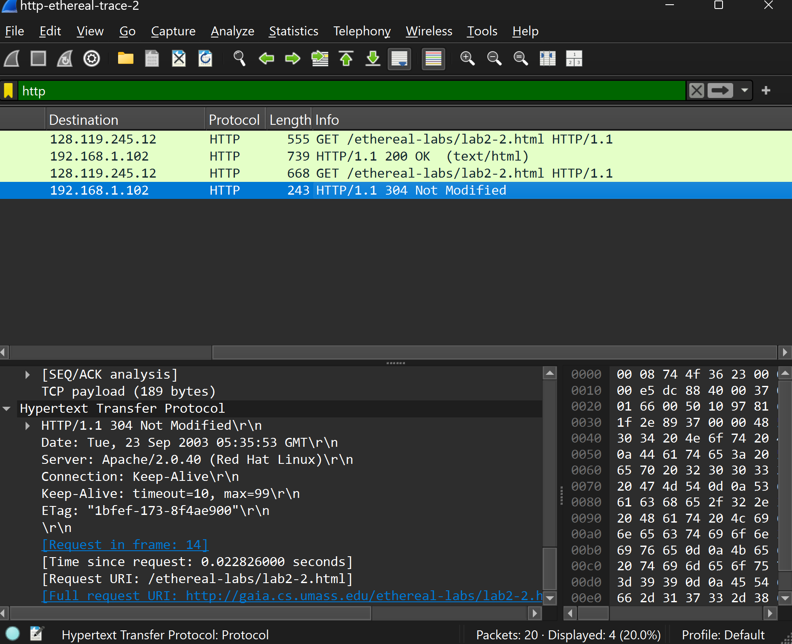

**In-Lab Statement 2 : Analyzing HTTP Protocol**

**Q1:** browser sent a total of **one** HTTP GET request messages.

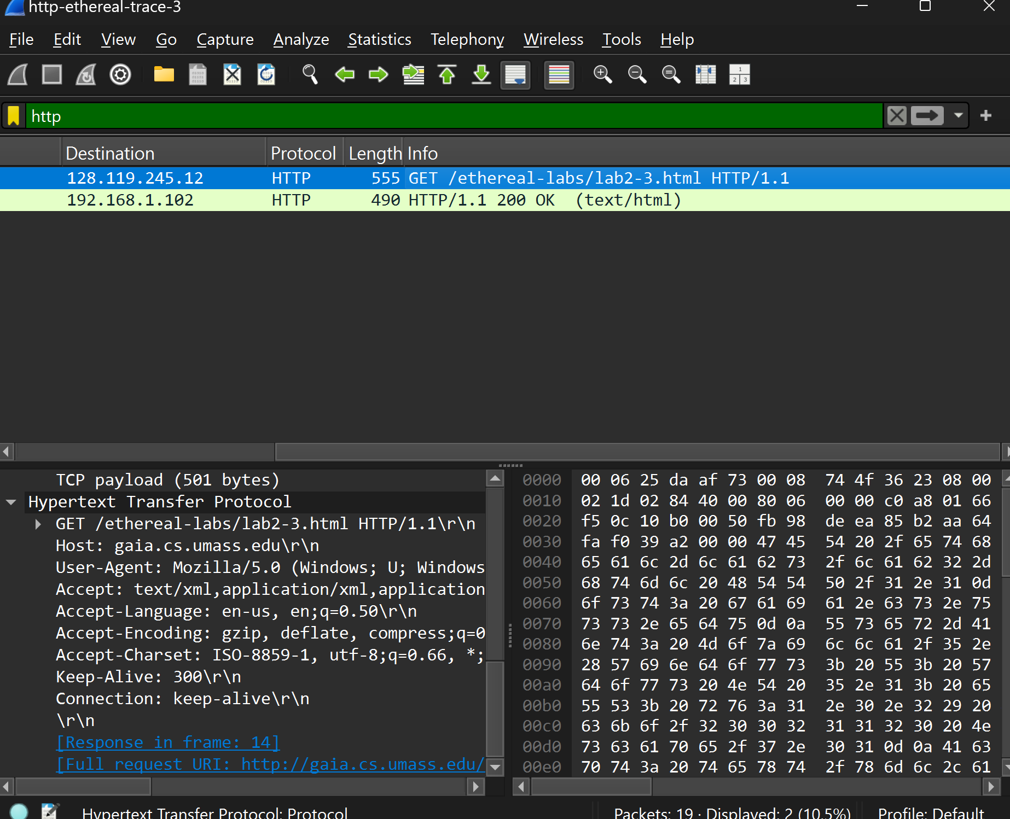

**Q2:** The packet number containing the GET message for **The Bill of Rights** is **8**.

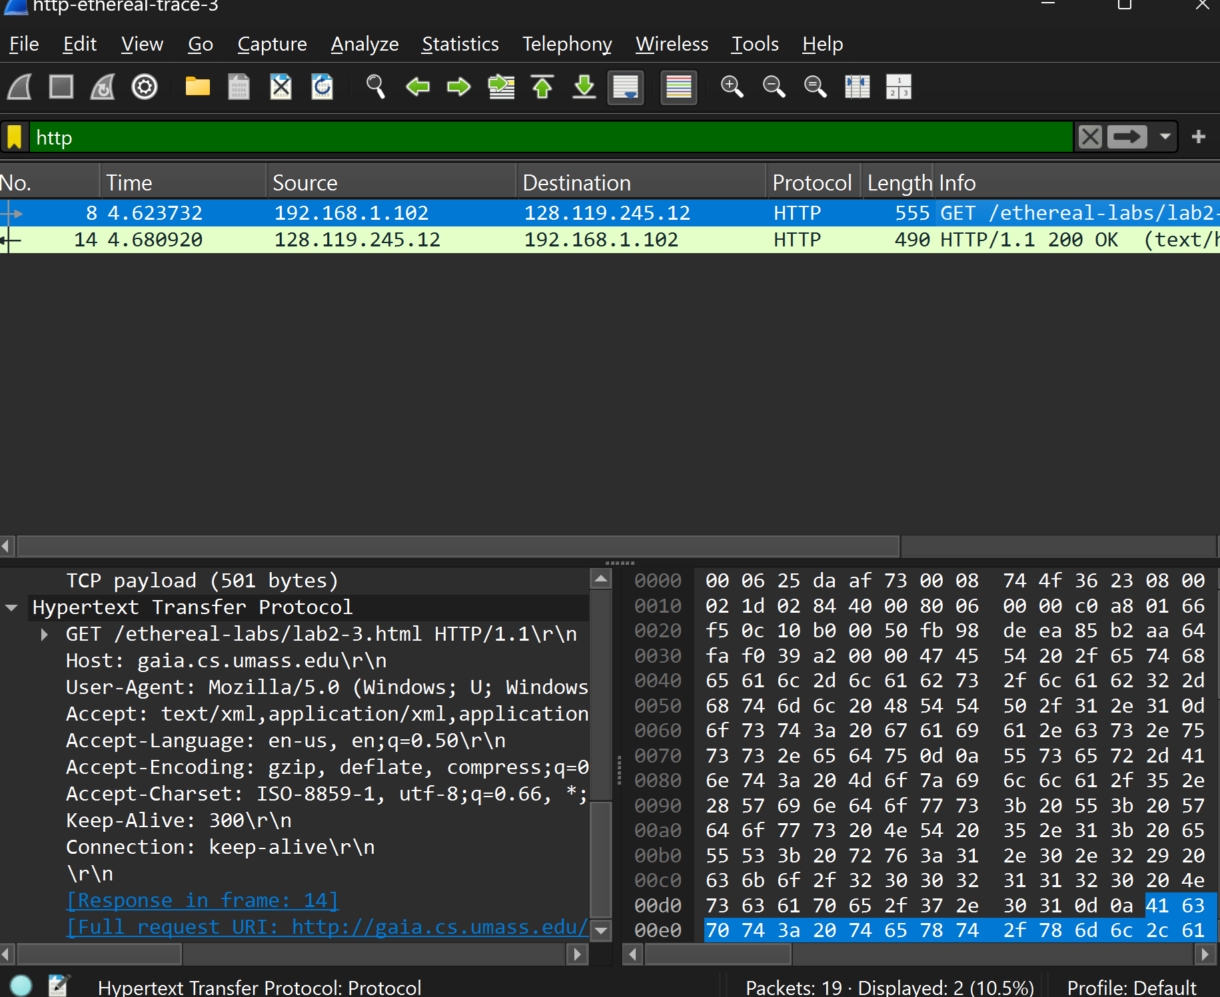

**Q3:** The packet number that contains the status code and phrase associated with the response to the HTTP GET request is **14**. This packet shows the response with **HTTP/1.1 200 OK**.



**Q4:** The status code in the response is **200**, and the phrase is **"OK."**



**Q5:**

1. **Total Content Length**: 4500 bytes
2. **Size of Each Segment**: 436 bytes

**Number of Segments:**

Number of Segments=4500/436≈10.3

**Total Segments Needed**: **11**

**In-Lab Statement 3: Trick Question**

**Length of the text for The Bill of Rights**: 4500 bytes.

**Justification**: The Response Packet Size of 490 bytes includes headers and part of the content, not the full text.

**Explanation**:

1. Content-Length is 4500 bytes.
2. First packet: 490 bytes (headers + some content).
3. Remaining content: 4500 - 490 = 4010 bytes.
4. Each subsequent packet carries 436 bytes.
5. Number of additional packets needed: 4010 / 436 ≈ 9.2, so 10 packets.
6. Total segments: 1 (490 bytes) + 10 (436 bytes each) = 11 segments to reach 4500 bytes.